50 years

INDIAN SOCIETY OF LABOUR ECONOMICS

GOLDEN JUBILEE CONFERENCE
13-15 December, 2008

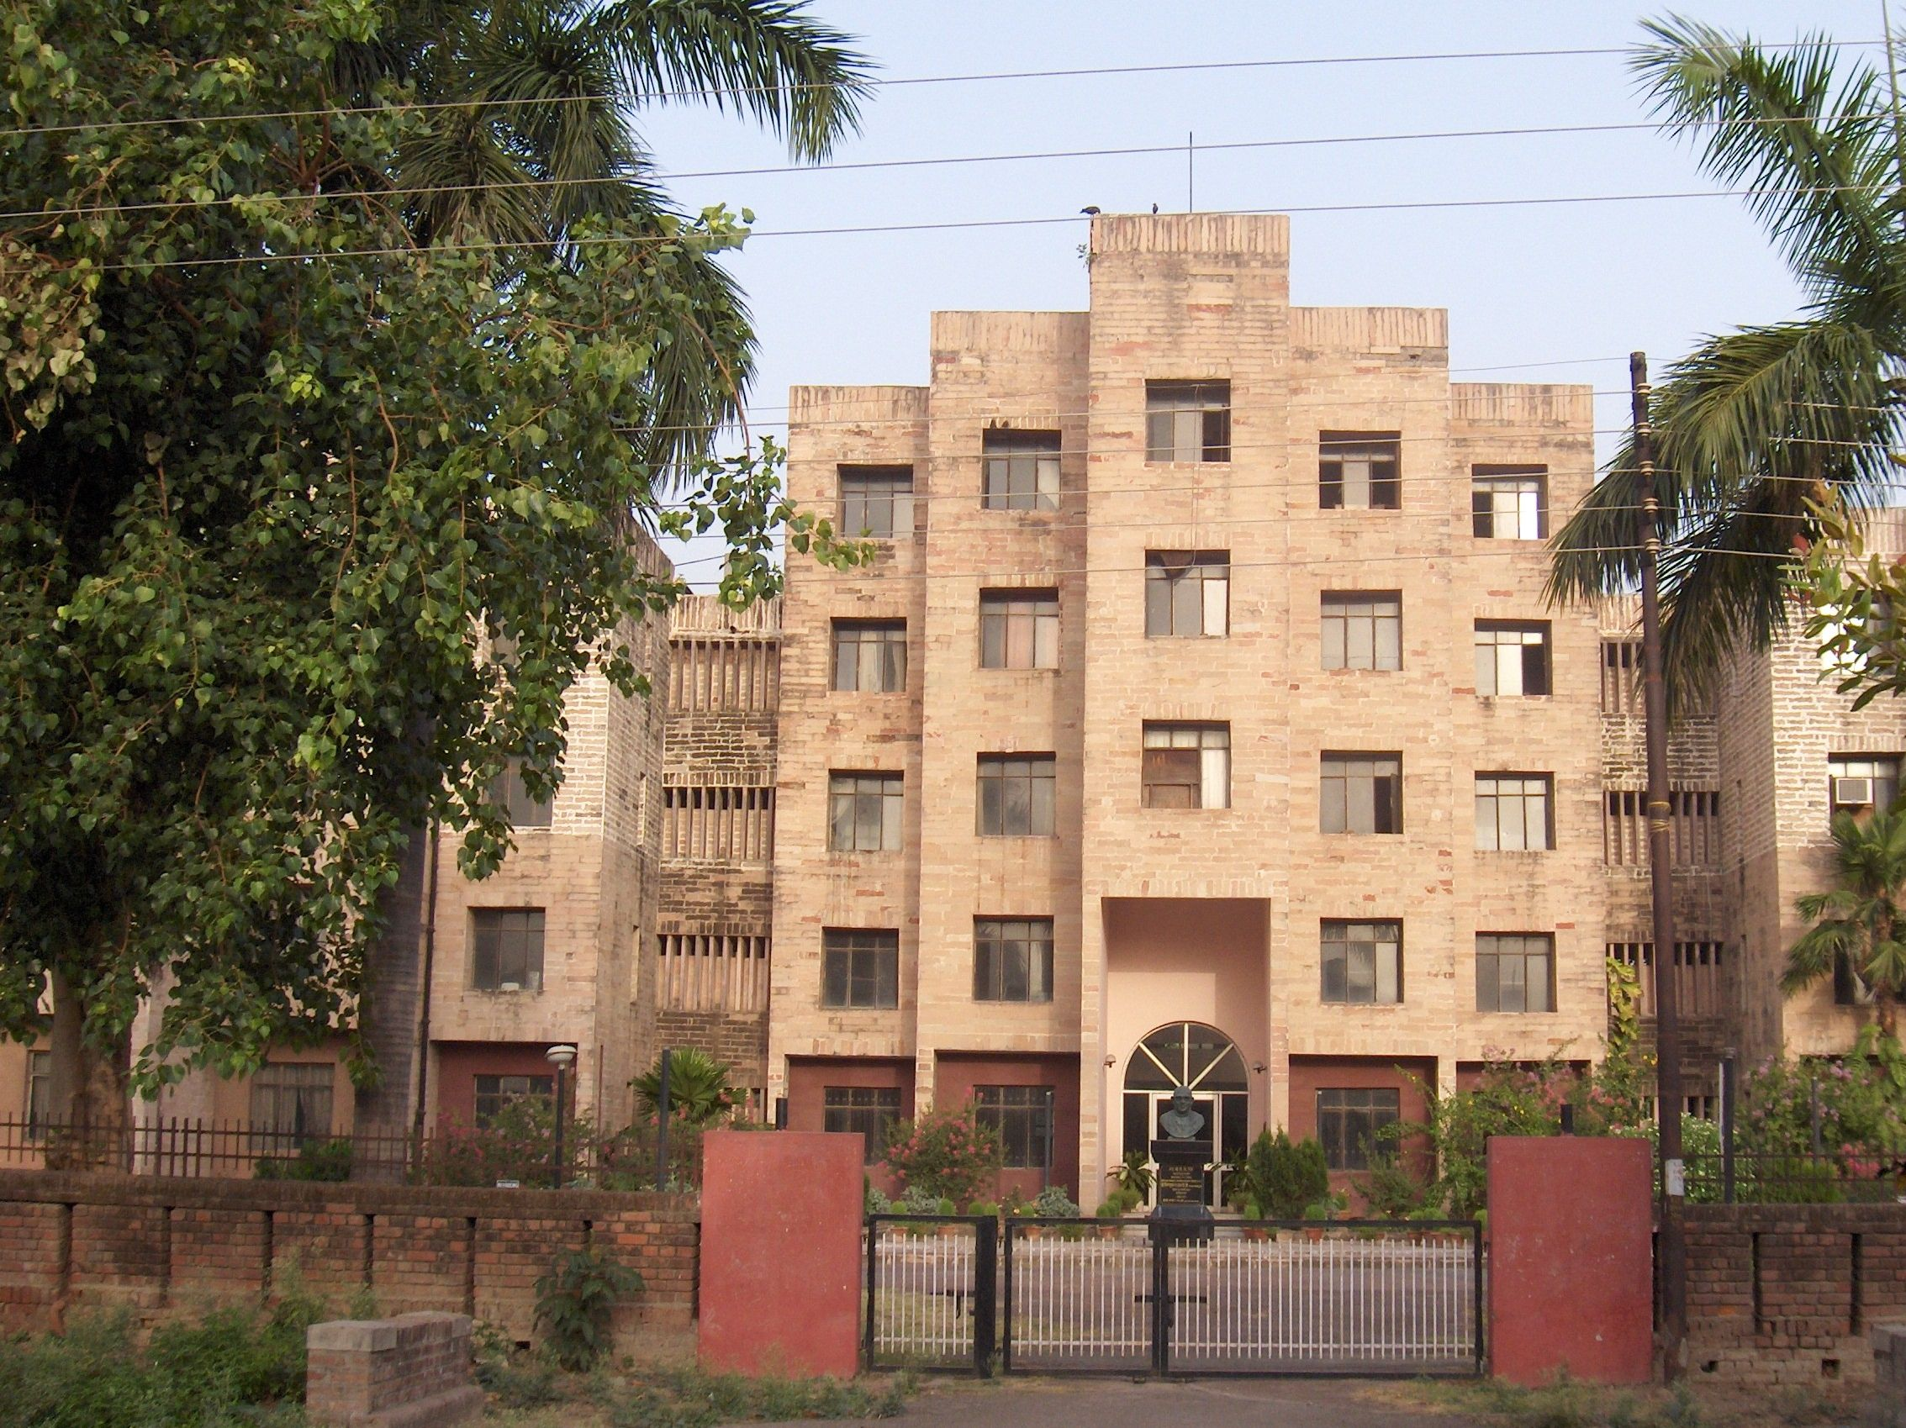



Organised by

Giri Institute of Development Studies, Lucknow
in Collaboration with
Lucknow University, Lucknow
and
Indian Institute of Management, Lucknow

Invitation

The Giri Institute of Development Studies, Luclnow in association with the Lucknow University, Lucknow and the Indian Institute of Management, Lucknow and feels great pleasure in inviting the esteemed members of Indian Society of Labour Economics to attend the Golden Jubilee Conference of the ISLE being held at Lucknow during December 13-15, 2008.
The selected themes of the conference are:
1. Globalization, Labour Markets and Employment
2. Women Workers in the New Economy
3. Education and Skills for the Emerging Labour Market
4. Labour Organisations in Independent India

For details of the themes please visit the web site of the ISLE: www.isleijle.org

Submission of Papers
Researchers and professionals are invited to contribute papers on the Conference Themes. Papers may be sent in the name of the Hony. Secretary, The Indian Society of Labour Economics, NIDM Building, IIPA Campus, I.P). Estate, Mahatma Gandhi Marg, New Delhi 110 002, on E-Mail: isleconference@gmail.com. Papers must not exceed 7500 words (including Tables and Appendices) and should be accompanied by a Summary in about 500-700 words. The summaries of all papers accepted will be published and distributed among Conference Participants. Papers should be submitted by 30 September 2008. All queries about the papers are to be directed to the Hony. Secretary, ISLE, New Delhi. Please don’t send papers to the Giri Institute of Development Studies.

About the Giri Institute of Development Studies, Lucknow
The Institute was established in 1973 as an autonomous research Institute. In 1977 it was brought within the umbrella of the Indian Council of Social Science Research (ICSSR) and was accorded the status of an Institution of national importance and has since been receiving regular financial support from the ICSSR and the Government of Uttar Pradesh.
Since its inception the Institute has established itself as a reputed centre of research on development issues with special focus on Uttar Pradesh and its various regions. The Institute has completed 270 research studies sponsored by various national and international organization and published 67 books.

About Lucknow

Situated on the banks of the river Gomti, the city of Lucknow traces its origin to the ancient times and is associated with the name of Lakshman, the brother of Lord Rama. The city acquired importance during the medieval period. The city, however, reached its zenith of glory when the Nawabs of Awadh made it their capital during the eighteenth century. It saw a flurry of architectural activity during the Nawabi rule and acquired its fame as the city of najakat (delicacy) and nafasat (refinement). The city played a key role during the First War of Independence 1857. The architecture and culture of the city found a modern flavour when the British made it the capital of the United Provinces of Oudh and Agra in 1920. Today it is an important centre of education in northern India with a large number of reputed schools and institutions of higher learning and research.
Climate
During December climate of Lucknow is pleasant but cool. The temperature varies from 6 degree Celsius during the night to 22 degree Celsius during the day. It is advisable to to bring heavy woollen clothes with you.
Arrival and Reception
Conference will be formerly inaugurated in the morning of 13th December, 2008 at 9.30 A.M. Delegates should plan to reach Lucknow by the evening of 12th December or early morning on 13th December. The delegates will be received at Airport and Railway Station. To avoid any inconvenience, the delegates should inform in advance their arrival programme. Taxis and auto rickshaws are available at the airport, railway station and bus stand. The Institute is situated approximately 12 km from Charbagh Railway Station, 14 km from Bus Stand and 24 Km from airport.
How to Reach Lucknow
Lucknow is accessible from every part of India through air, rail and road. There are direct flights from New Delhi, Patna, Calcutta and Mumbai to the city. Similarly city is linked to north, east, south and west through rail and road links. Details of main flights and trains are given for your convenience.
By Air:
Routine | Flight Name | Departure | Arrival
From Delhi/New Delhi
DAILY | S26137/ S26138 | 605 | 705
DAILY | IT651/ IT652 | 730 | 825
DAILY | IC411/ IC412 | 805 | 900
DAILY | DN524/ DN525 | 1145 | 1310
DAILY | 9W725/ 9W726 | 1545 | 1645
DAILY | IC811/ IC812 | 1605 | 1700
DAILY | IT653/ IT654 | 1905 | 2000
DAILY | DN779 | 935 | 1420
From Mumbai
DAILY | S2665/ S2666 | 625 | 830
DAILY | IC195/ IC195 | 630 | 830
DAILY | DN779/ DN780 | 1210 | 1420
DAILY | S2667/ S2668 | 1650 | 1905
From Kolkata
DAILY | S26361/ S26362 | 1900 | 2025
By Rail:
Train No. | Train Name | Departure | Arrival
From Delhi/New Delhi
2230 | LUCKNOW MAIL | 22:00 | 06:50
2230A | NDLS LKO SUP SP | 23:30 | 07:15
2392 | SHRAMJEEVI EXP | 13:15 | 21:15
2554 | VAISHALI EXP | 19:50 | 03:50
2556 | GORAKHDHAM EXPRES | 20:20 | 04:50
2558 | SAPT KRANTI EXP | 15:00 | 22:25
2566 | BIHAR S KRANTI | 14:30 | 21:50
4258 | KASHI V EXPRESS | 13:30 | 23:00
5610 | AVADH ASSAM EXP | 07:55 | 17:45
From Mumbai
1015 | KUSHINAGAR EXP | 22:55 | 01:45
2107 | LUCKNOW SUP EXP | 16:25 | 15:05
2534 | PUSHPAK EXPRESS | 08:20 | 08:40
9037 | AVADH EXPRESS | 22:40 | 06:25
From Chandigarh
2232 | CDG LKO EXPRESS | 20:50 | 08:30
From Kolkata
3005 | AMRITSAR MAIL | 19:10 | 15:25
3009 | DOON EXPRESS | 20:35 | 18:05
3019 | BAGH EXPRESS | 21:45 | 00:40
3049 | AMRITSAR EXP | 14:00 | 15:35
From Ahmedabad
9165 | SABARMATI EXP | 20:50 | 00:50
From Chennai
2512 | RAPTISAGAR EXP | 23:15 | 09:50
Accomodation

The accommodation will be arranged in modest hotels and guest houses. However, on request the organizers can arrange luxury accommodation on payment basis. Filled in Registration Forms along with a DD of Rs. 600 per member of Indian Society of Labour Economics and Rs. 1000/- each for each non- member should be sent in favour of “ISLE Golden Jubilee Conference” payable at Lucknow latest by 15th November. Registration fee includes conference kit, boarding and lodging. It will be difficult to arrange suitable accommodation in case of later registration.

Registration Fee
 | Indian (Rs.) | Overseas (US $)
ISLE Members | 600 | 100
Non-Members | 1000 | 175
Spouse/Accompanying person | 500 | 75

Online registration and payment facility is also available on ISLE website.
Conference Venue
The conference will be held at the Institute campus.
Looking forward to seeing you at Lucknow during the conference.

Prof. Ajit Kumar Singh
Local Organising Secretary

For any other information please contact the Local organizing Secretary or the Joint Secretaries at the following address:

Professor Ajit K. Singh
Organizing Secretary, ISLE Golden Jubilee Conference
Giri Institute of Development Studies
Sector O, Aliganj Housing Scheme
Lucknow 226 024 (U.P.), INDIA
Phones: 91-522 2321860, 2325021, Telefax: 91-522-2373640
E-Mail: gids@sancharnet.in
Aksingh101@rediffmail.com

Other Contacts:
Prof. Ashutosh Joshi
Joint Organising Secretary
Giri Institute of Development Studies
Sector O, Aliganj Housing Scheme
Lucknow 226 024 (U.P.), INDIA
Phones: 91-522 2321860, 2325021,
Telefax: 91-522-2373640

Dr. Nomita P.Kumar
Joint Organising Secretary

Giri Institute of Development Studies
Sector O, Aliganj Housing Scheme
Lucknow 226 024 (U.P.), INDIA
Phones: 91-522 2321860, 2325021,
Telefax: 91-522-2373640
E-Mail: nomita_@rediffmail.com
nomita.kumar36@gmail.com

HOW TO REACH GIDS

Participants coming by Flight kindly look for the person with GIDS placard as you come out of the arrival lounge. In case you do not find our representative please hire a pre paid taxi for Aliganj Sector O. The charges are around Rs. 350. The major landmark on the route are cantonment, Hazratganj, University, Kapoorthala crossing, Purania Crossing and Goyal crossing on route to engineering college.

Participants coming by train kindly come to the railway enquiry office in the main hall outside platform 1 near the first class booking office and look for the person with GIDS placard. In case you do not find our representative please hire a pre paid taxi or auto available just outside the station for Aliganj Sector O. The charges are around Rs. 150 for taxi and Rs. 60 for auto. The major landmark on the route are Hazratganj, University, Kapoorthala crossing, Purania Crossing and Goyal crossing on route to engineering college.

The Institute is located near Goyal crossing between Usman Enclave and City Montessori School, Sector O.

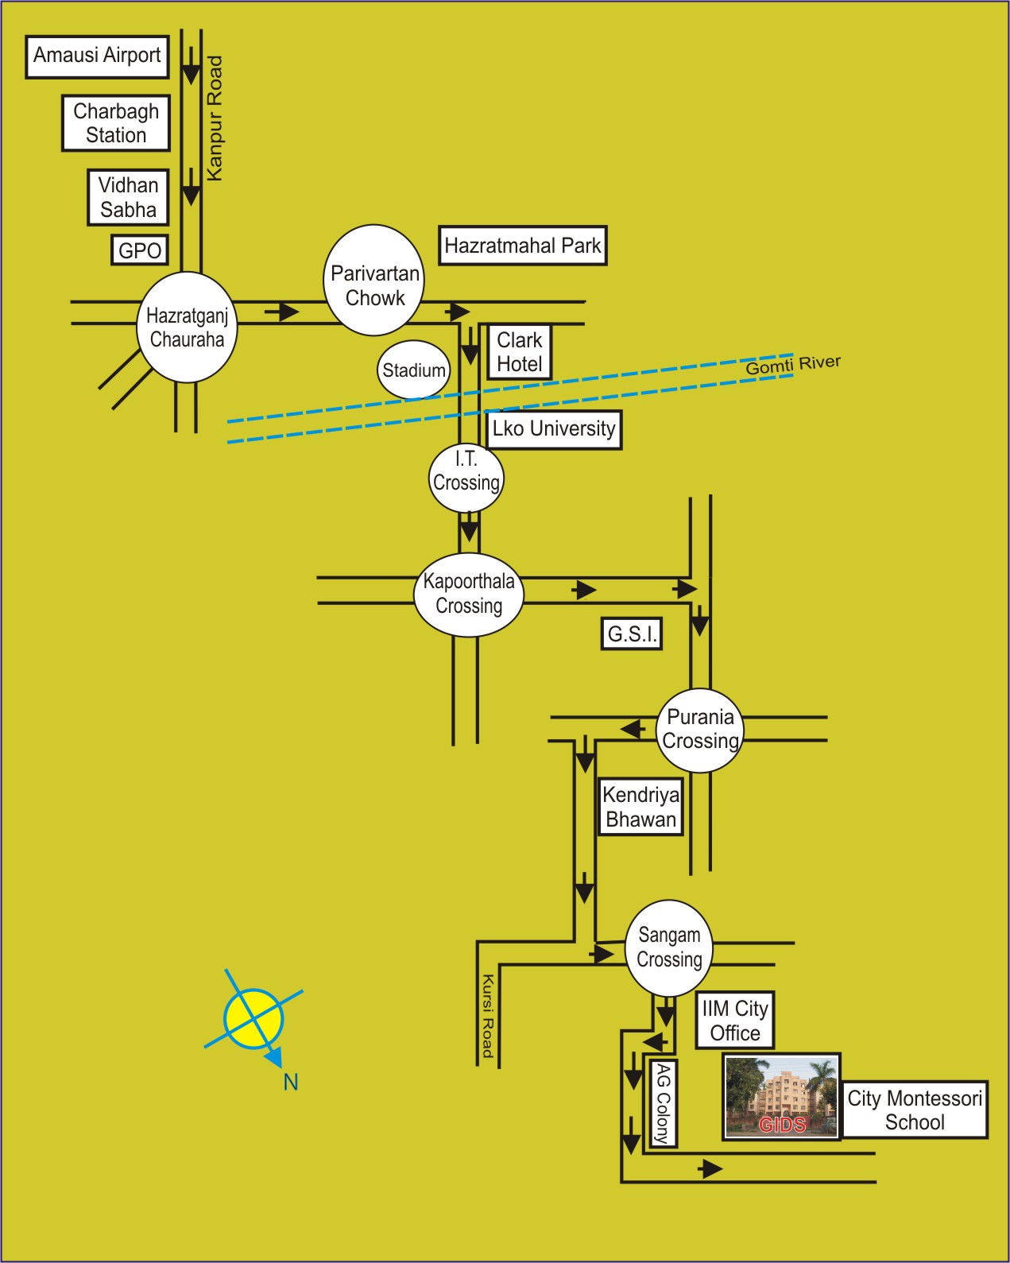

INDIAN SOCIETY OF LABOUR ECONOMICS

GOLDEN JUBILEE CONFERENCE

Registration Form

Name _______________________________________________

Designation _______________________________________________

Organization _______________________________________________

Address _______________________________________________

_______________________________________________

Telephone(Office)_______________________(Residence/Cell) ________

E-Mail ID _______________________________________________

Arrival and ______________________________________________

Departure details __________________________________________

Accompanying person(s)

Name(s) _______________________________________________

Attached herewith DD No.____________ dated ________Amount _____

Accommodation required (Please write ‘Y’ for Yes and ‘N’ for No) __________

Signature _________________________

Send your duly filled-in Registration Form along with the registration fee through DD in favour of ISLE Golden Jubilee Conference, payable at Lucknow to:

Professor Ajit K. Singh
Local Secretary, ISLE Golden Jubilee Conference
Giri Institute of Development Studies
Sector O, Aliganj Housing Scheme
Lucknow 226 024 (U.P.), INDIA
Phones: 91-522 2321860, 2325021, Telefax: 91-522-2373640
E-Mail: gids@sancharnet.in

Alternatively, one can make on-line registration on the ISLE website.

